AURORA GAZETTE
Editorial Board

Mr. B. Mohan Kumar
Mr. G.N. Satish Kumar
Dr. D. Shireesha
Mrs. Arpitha
Mrs. T.V. Ratnavali
Mr. R. Bhadra Rao

Bulletin
Faculty achievements
NSS Activity
- Cancer awareness walk
Guest lectures
Placement activities
Cultural Festivities
- VasanthPanchami
- Aaharotsav
Important Dates in February

Director’s message

Dear Students,

The institution is striving to achieve standards of excellence by providing an environment of continuous learning and interaction with industry. Challenges and Opportunities are two sides of the same coin. Modern education, curriculum development and teaching methodologies have to keep pace with the demand of the economic environment. The manager, businessman and the entrepreneur of today needs many more weapons in armory. Holistic education should include all round development of a student. At Aurora, we continuously endeavor to achieve that overall development of the student. Apart from theoretical knowledge we offer practical knowledge with entrepreneurial skills.
Our MBA final year students have actively participated in a week long Entrepreneurship Development programme. The Students will organize an “Aahar Ustav” – A Food Festival. Each section will organize a food joint on each day of the week.
We have successfully organized a weeklong Faculty Development program (FDP) on Multivariate Data Analysis using SPSS and AMOS software. Our faculty has always been a trend setter but what has also been noteworthy is the excellent support and commitment of the non-teaching staff.

I wish you all the best for achieving greater success and scaling newer heights in your education and career ahead.

Editorial

Welcome to the February Issue of Aurora Gazette. This month was highlighted by a gamut of activities that were varied and interesting. Faculty members have presented papers in HR, Marketing and Finance at DYPIMS, Pune in a National Conference organized by them; a faculty member had been invited by a college for guest lecture; and two members of the college registered for the National Seminar to be conducted by Department of Management Studies, Osmania University. The students and faculty took part in Cancer Awareness Walk; two guest lectures that were informative of the soft skills required by management graduates were conducted; 25 students were selected in on campus and off campus placement drives. The lab exams for students of I semester MBA and I semester MCA were conducted in the first week of February. In the second week of the month, Aaharotsav was organized and students took an active part. An FDP on Multi Variate Data Analysis was the highlight of the third week of the month. This being the last of semester for 2014-16 MBA students, the final project seminars were scheduled and completed in the second week. Their reports are due to be submitted to Osmania University in the third week of March 2016.
The Aurora Founder’s Day which falls every year on Vasanth Panchami was celebrated on 12th February.
Thank you. We hope you will find Aurora Gazette informative
Please send your articles and other contributions to newsletter.apgm@gmail.com

FACULTY ACHIEVEMENTS
Paper presentation at a Two-Day International Conference, DYPIMS, Pune, Maharashtra on 4th and 5th February 2016
Mrs. K. Navyatha, Mrs. A. Shirisha Reddy, Ms. C. Deepika and Ms. G. Priyanka presented papers in International conference organized by DYPIMS, Pune and their papers are going to be published in the journal with ISBN Number published by the institute. The college congratulates them and hopes that all the faculty members involve themselves thoroughly in research and publish papers that are useful for the society.
Mrs. Renubala visited Hindi MahaVidyalaya as guest lecturer on 18th February 2016
Mr. B. Mohan Kumar, Director and Mr. V. Raghavendra, Associate Professor registered for National Seminar OU Campus Department of Management

FDP on Multivariate Data Analysis from 22nd to 28th February 2016

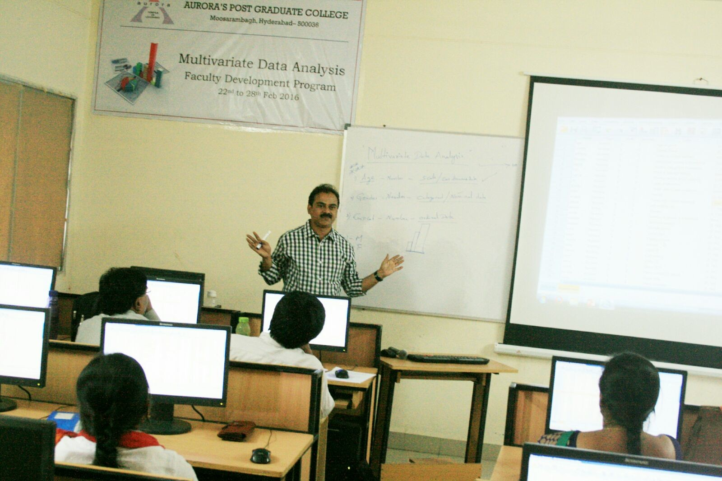

NSS ACTIVITY
Cancer Awareness Walk on 7th February 2016
With an aim to increase understanding, early detection and survival of cancer among people in the city, a cancer awareness walk would be organized on February 7 by Yashoda Hospital, Malakpet. The 4 km walk would commence by 8 am at Saroornagar stadium and proceed up to Kothapet and would be back to culminate at the stadium. The initiative is a part of cancer community services started by ‘Fight On’, a cancer community support program started by Yashoda Group of Hospitals to help conquerors of cancer, beyond providing superior medical treatment. The students of the college under the leadership of Mr. R. Bhadra Rao, Assistant Professor have voluntarily participated in the program by participating in the walk and educating their college mates the next day.
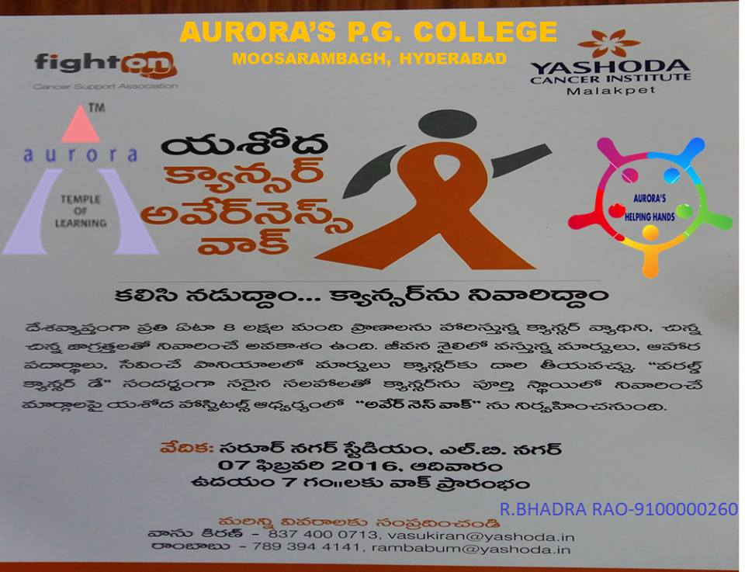

GUEST LECTURES
A guest lecture on development of soft skills was organized on 8th February, 2016 and the session was taken up by Mr. Manoharan, Manager, SBI, who alerted the students on the requirements of the industry and the skills that need to be developed by them. By quoting live examples, making students play management games on team work and leadership skills, and by discussing personal experiences that he came across in his career, he highlighted human skills that are essential for interviews and career development.
On 22nd February 2016, Mr. Raghu, Smartsteps Consulting Pvt. Ltd. gave a guest lecture to the students of MBA IV semester on the accounting skills wanted by the industry. He stressed upon the need to keep updated about emerging trends in financial field and said that students have to study these trends and should be able to interpret them.

NSIC WORKSHOP
The students of IV semester MBA attended a workshop at NSIC Marketing cum Business Park. Mr. Nagarjuna, Associate Professor supervised the visit and introduced the students to the chief speaker who hails from Tech Mahindra. 100 students have participated in this session and got hands-on knowledge on entrepreneurial skills.

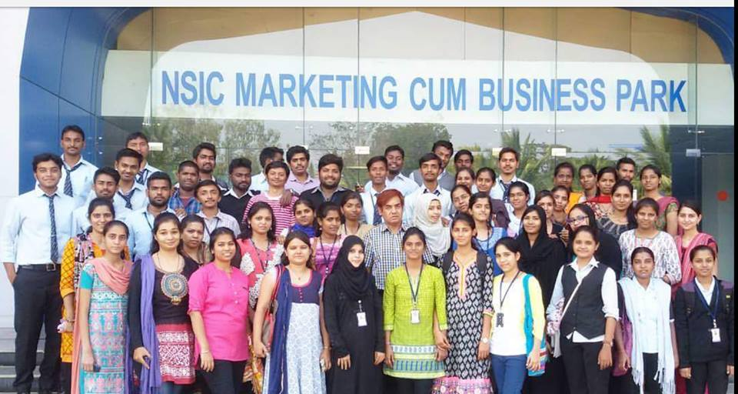

PLACEMENT ACTIVITIES
Indus Ind placement drive took place at at ABS on 5th Feb
Kotak Mahindra Placements was organized on 11th Feb at Aurora’s PG College,Ramanthapur
The college hosted placement drives of ICICI Prudential and Store G Online Bazaar on 23rdand 24th February 2016.
SL No | ROLL NO | NAME | COMPANY
1 | 2122-14-672-138 | H CHETNA | STORE-G ONLINE BAZAR
2 | 2129-14-672-014 | DACHANA RANI | STORE-G ONLINE BAZAR
3 | 2122-14-672-162 | K SAI RAM | STORE-G ONLINE BAZAR
4 | 2129-14-672-068 | GURU PRASAD G K | STORE-G ONLINE BAZAR
5 | 2122-14-672-084 | GANJI PRAJWAL | STORE-G ONLINE BAZAR
6 | 2129-14-672-069 | VIDYA SAGAR | STORE-G ONLINE BAZAR
7 | 2122-14-672-166 | P PRADEEP KUMAR | STORE-G ONLINE BAZAR
8 | 2129-14-672-028 | CHAUHAN ANKUSH | STORE-G ONLINE BAZAR
9 | 2129-14-672-095 | ERUGALA SAI SACHIN KUMAR | STORE-G ONLINE BAZAR
10 | 2129-14-672-123 | PREETHAM MADHAMSHETTY | STORE-G ONLINE BAZAR
11 | 2122-14-672-100 | KUMMARI ANIL KUMAR | STORE-G ONLINE BAZAR
12 | 2129-14-672-107 | HANMAKONDA RAVINDAR | ICICI PRUDENTIAL
13 | 2129-14-672-092 | B ANURAG | ICICI PRUDENTIAL
14 | 2129-14-672-126 | KODELA CHANDRAMOULI | ICICI PRUDENTIAL
15 | 2122-14-672-025 | PARASHAR KIRAN | ICICI PRUDENTIAL
16 | 2122-14-672-012 | NAGEKER CHAITANYA | ICICI PRUDENTIAL
17 | 2122-14-672-037 | ERAVELLI SAIKUMAR | ICICI PRUDENTIAL
18 | 2122-14-672-139 | K VASAVI | ICICI PRUDENTIAL
19 | 2122-14-672-008 | KRUTHIVENTY SANTOSHI SRAVYA | INDUSIND BANK
20 | 2122-14-672-003 | BHARATHI ROOPANI | INDUSIND BANK
21 | 2129-14-672-001 | RANJANA MISHRA | INDUSIND BANK
22 | 2122-14-672-002 | K POOJA | INDUSIND BANK
23 | 2129-14-672-090 | MALLIPATEL SWEATHA | INDUSIND BANK
24 | 2122-14-672-001 | BALI BHARATH | INDUSIND BANK
25 | 2122-14-672-004 | ACHANTA PARIMALA | S&P CAPITALIQ

CULTURAL ACTIVITIES

VasanthaPanchami, Founders Day on 12th Feb 2016

VasanthPanchami was the day of the inception of Aurora Group of Institution and is being celebrated as Founder’s Day. This year, it was celebrated on 12th February, 2016. The idol of Saraswathi was worshipped, Bhajans were sung and Puja was conducted. In his speech the Director, Mr. B. Mohan Kumar talked about the significance of VasanthaPanchami and went about to speak of the evolution of Aurora Group of Institutions and the practice of upholding our Indian culture which is the hallmark of Aurora.

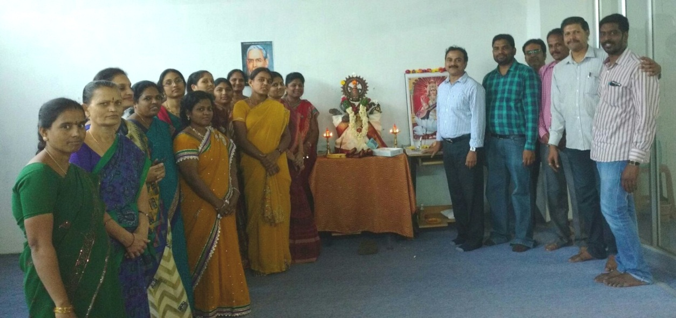

Aaharotsav 15th to 20th Feb

Aaharotsav is an event celebrated every year. Hosted by the students of MBA final year students it is a week long celebration in which students exhibit their entrepreneurial and management skills. Students of each section takes a day to run business, preferably a hotel. It is evaluated on the basis of profits, revenue and expense statement, neatness, taste of food and other criteria. The winners will be awarded prizes on the Annual Day.
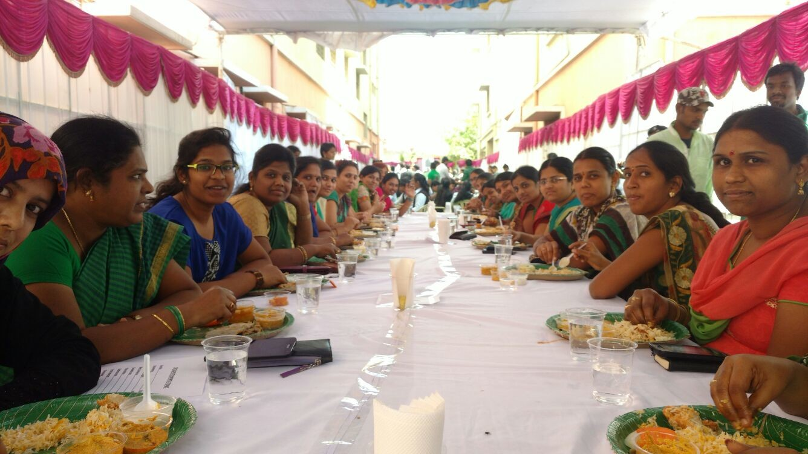

IMPORTANT DATES
- MBA I sem exams conclude on 8th Feb 2016. Their second semester classes commenced from 10th February 2016.
- MCA I sem exams from Feb 8th – 15th 2016.
- Commencement of MBA and MCA II sem classes 10th Feb
- Project Seminars – 10th, 11th and 12 Feb

REALITY BYTES
Faculty attended National Conference at Pune
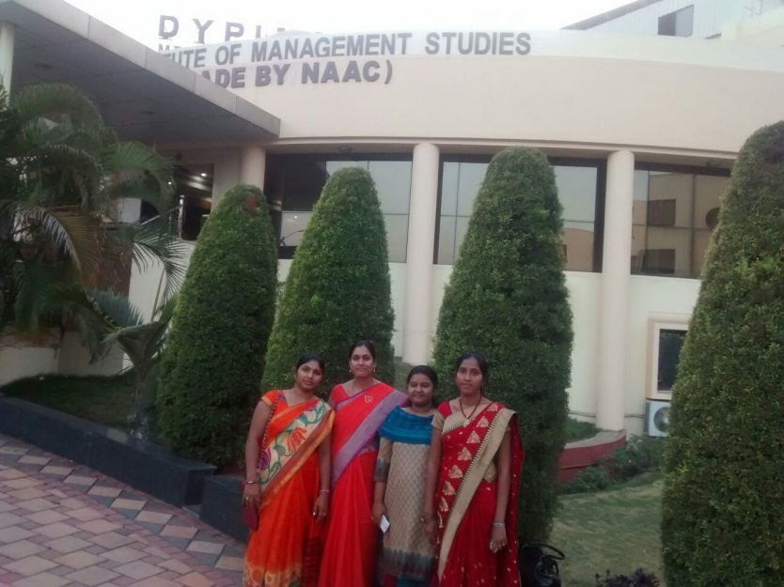
Cancer walk
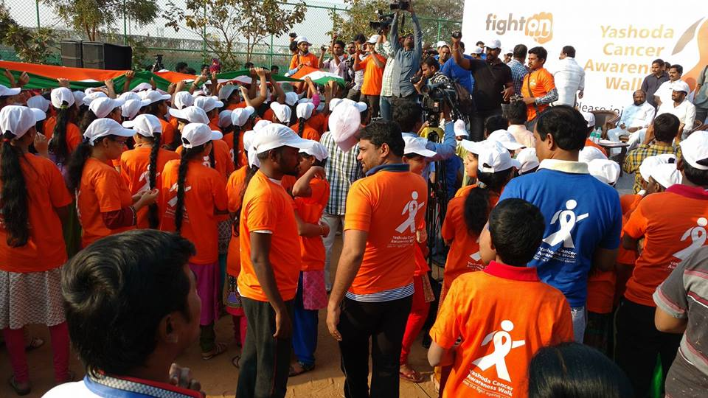

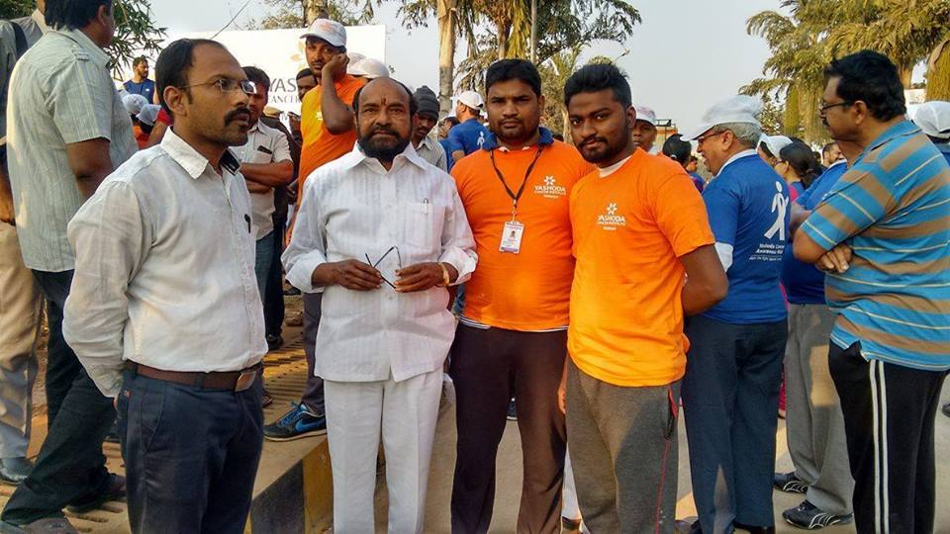

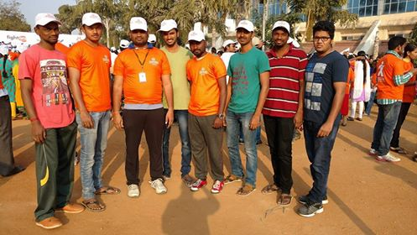

Aaharotsav
Dr. Ramesh Nimmatoori, Secretary, Aurora Consortium cutting ribbon and beginning the event
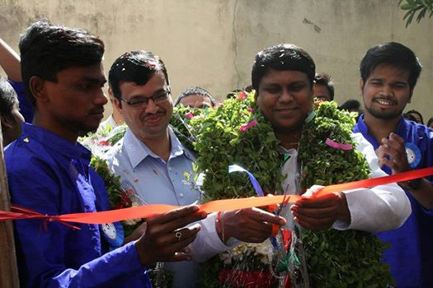

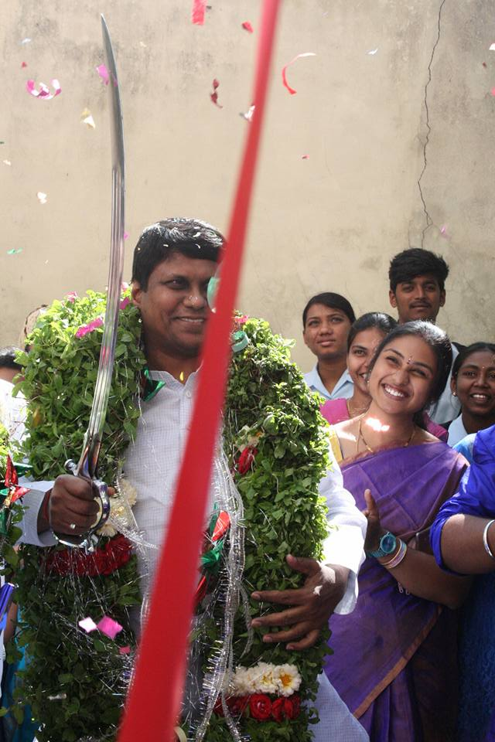

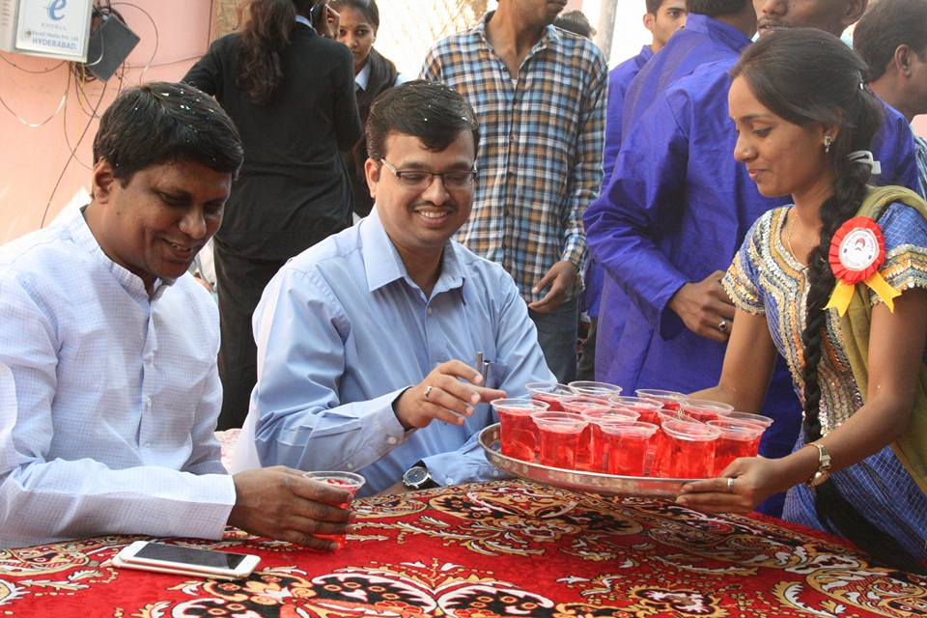

A SECTION’S ‘A’SHAN PREET (FOOD LOVERS)

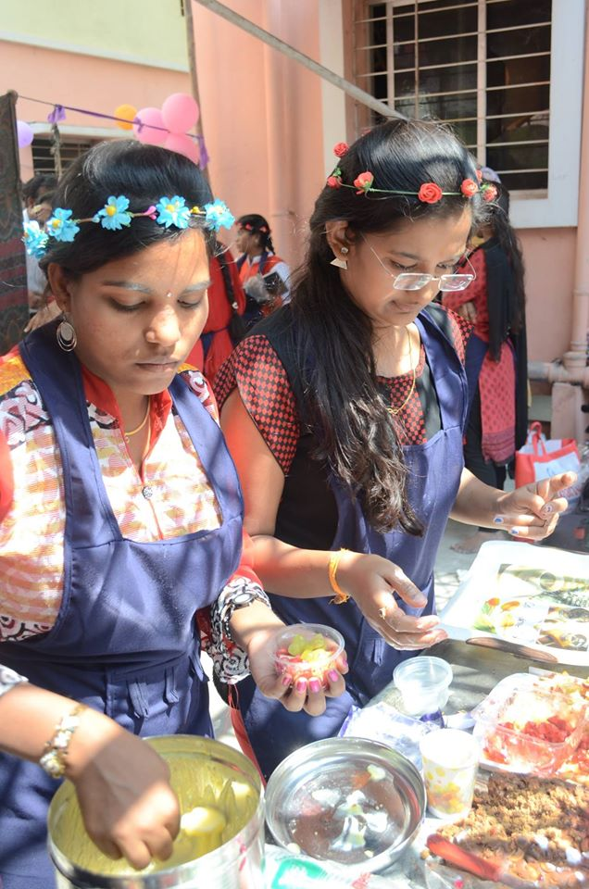
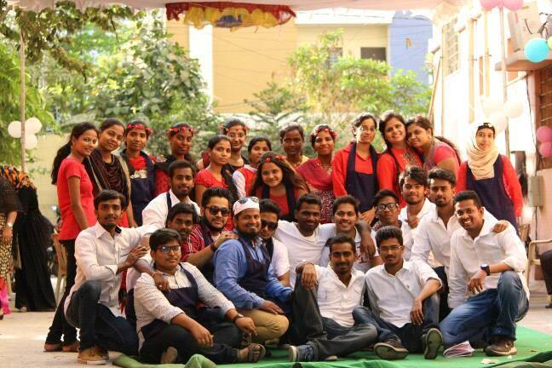

B SECTION’S BINDAAS EXPRESS AT ‘B’AWARCHI JUNCTION

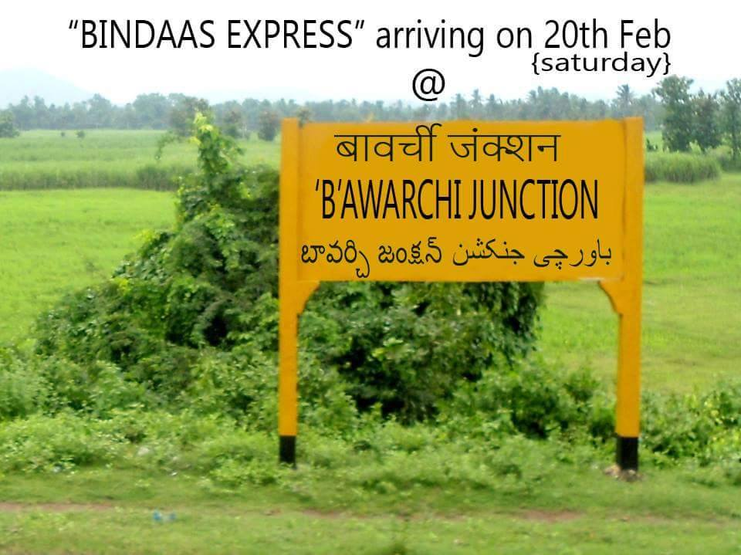

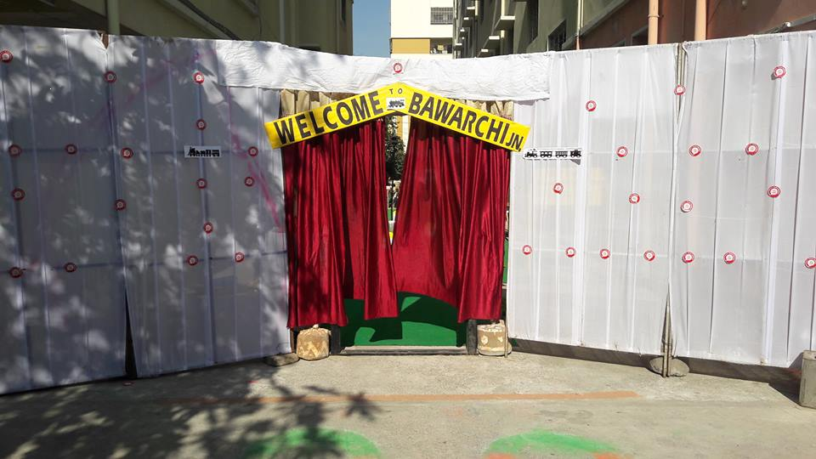

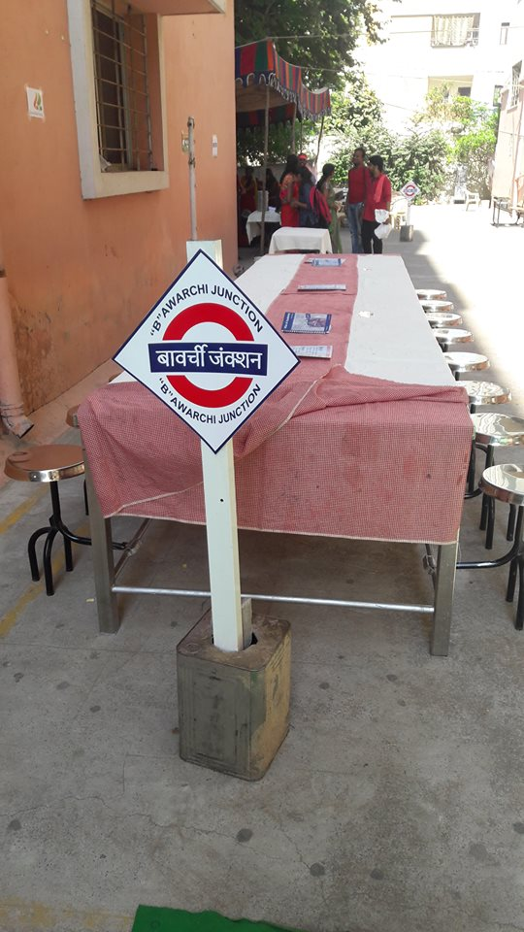

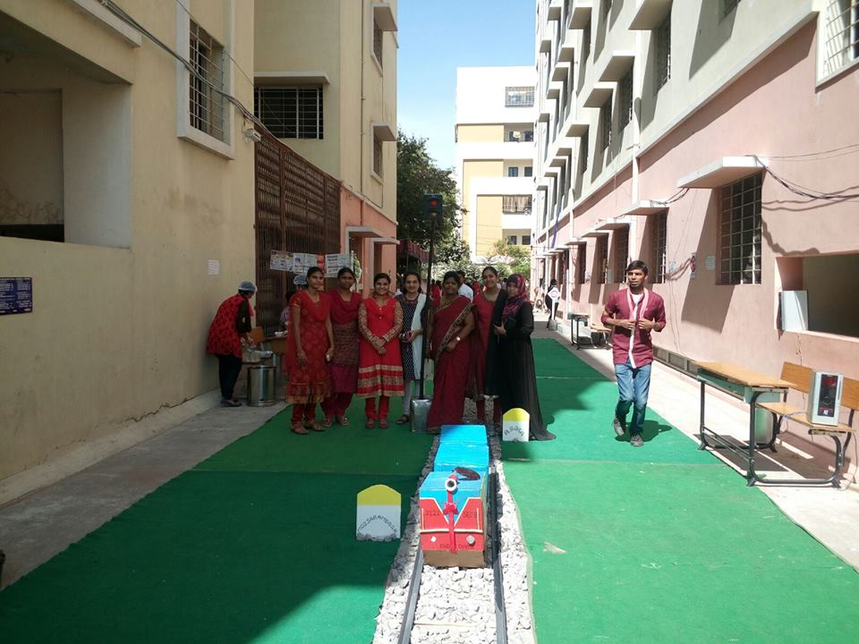

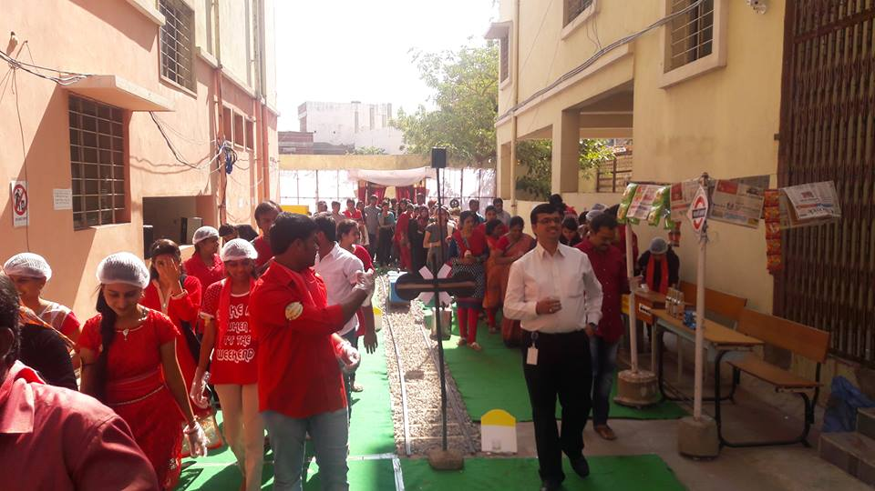

SECTION C-‘C’RISP’S IN B&W DRESS CODE WITH COLORFUL MENU

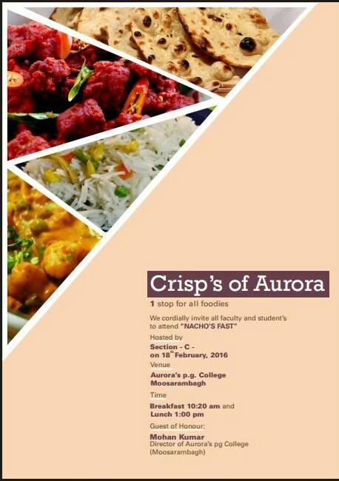

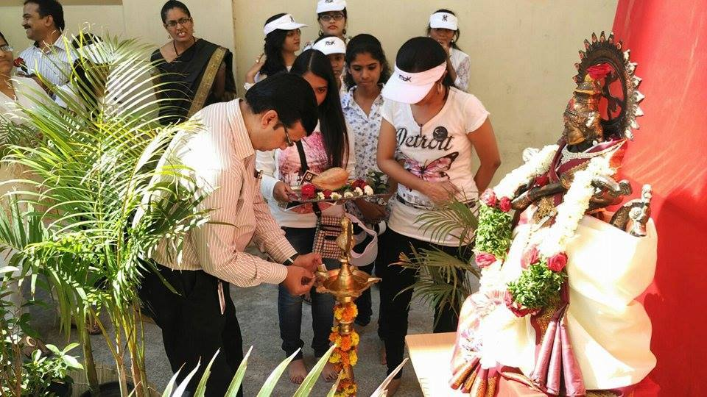

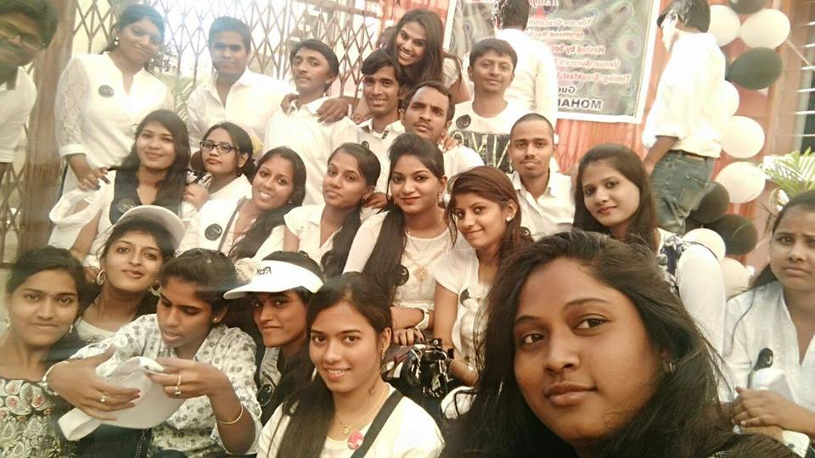

D SECTION’S PALANGTODH ‘D’HABA

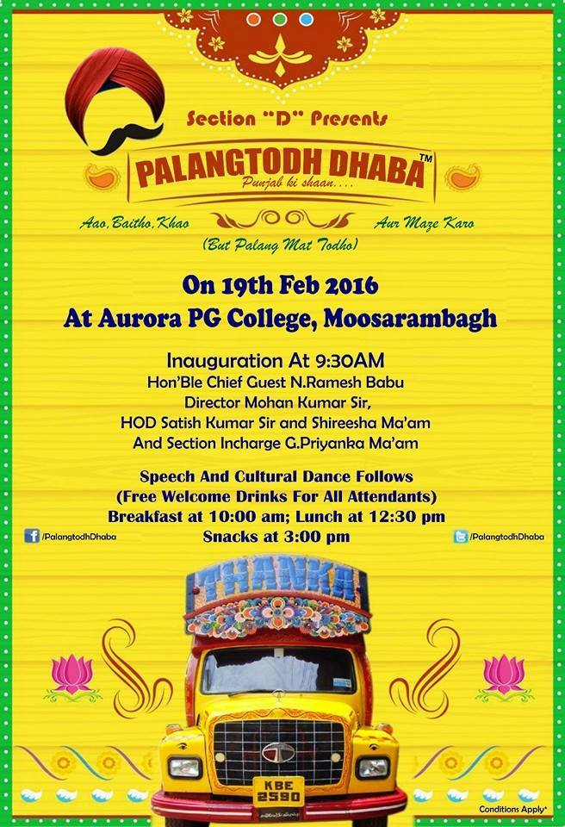

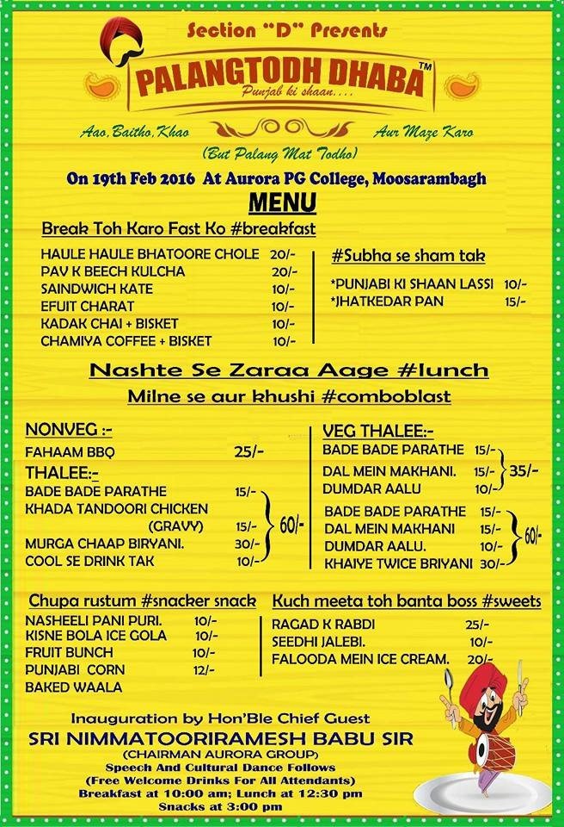

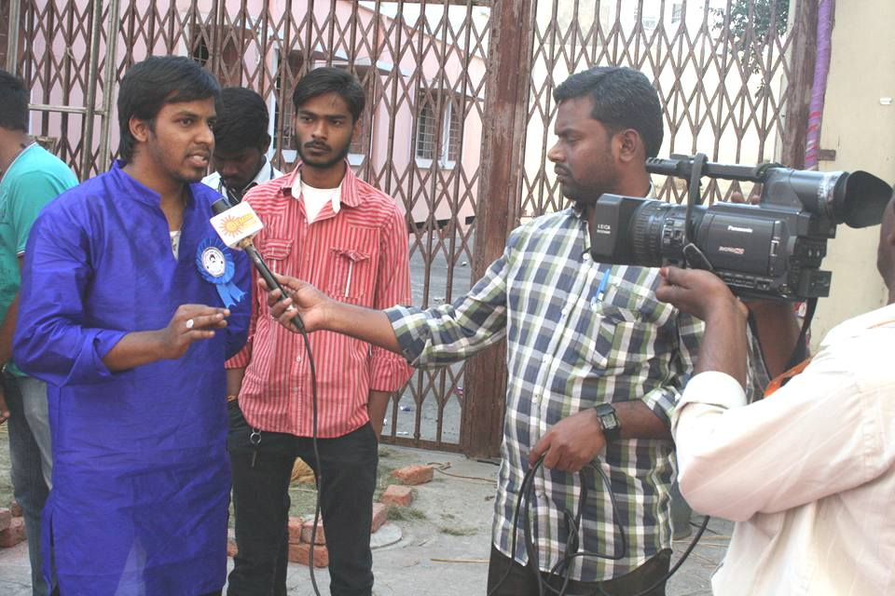

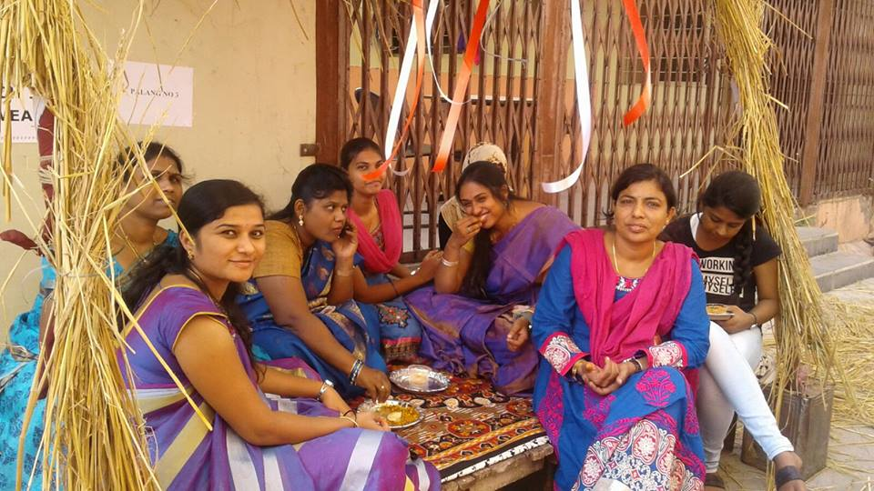

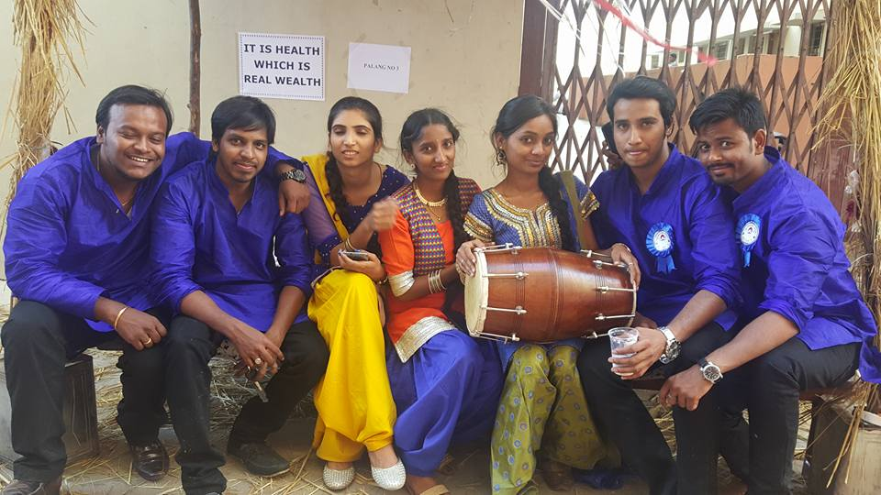

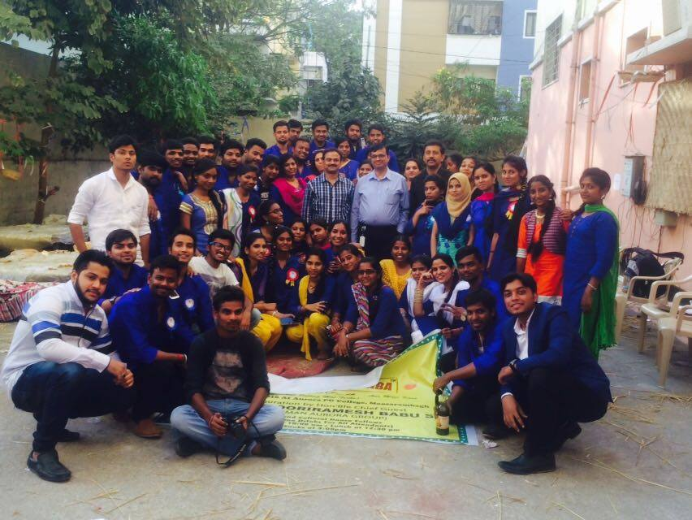

Memento to Secretary
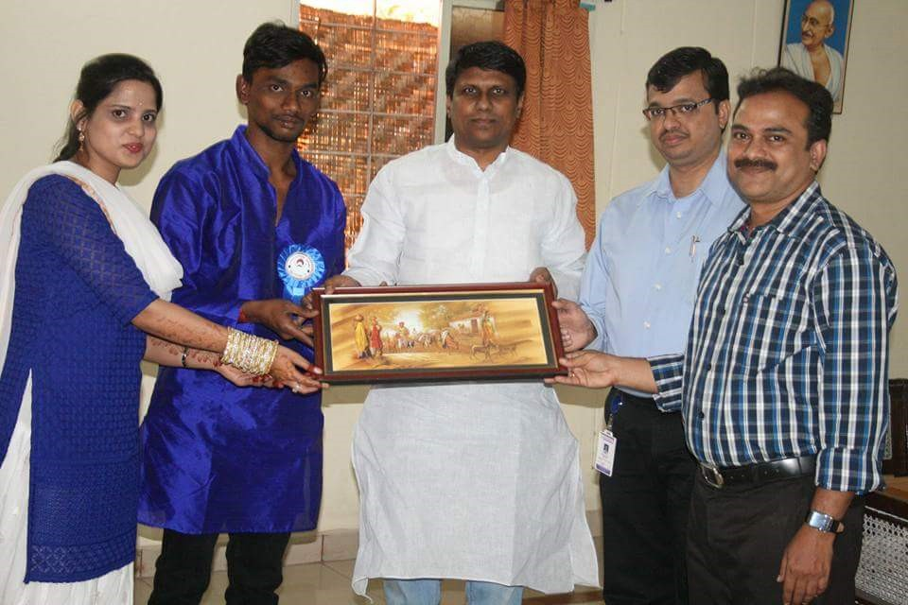

THE E SECTION NAWAB-‘E’ HYDERABAD
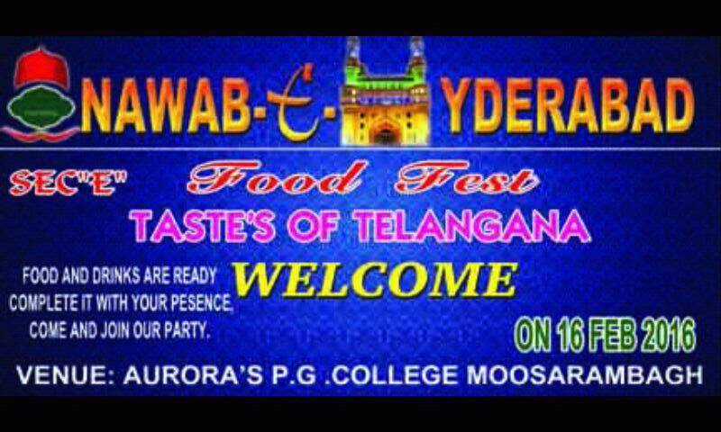

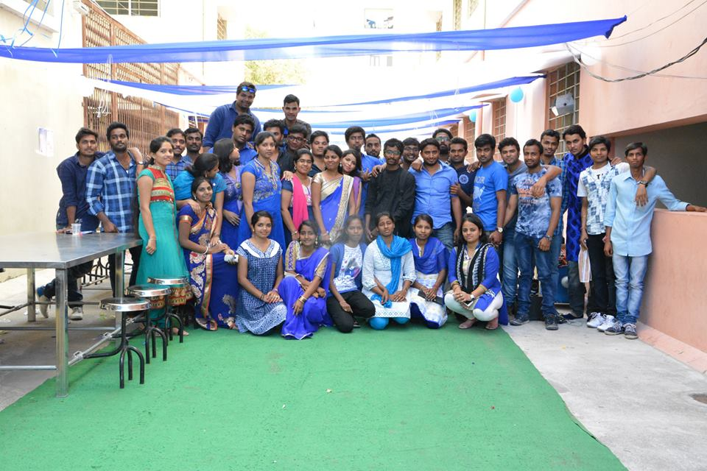

‘DOWN TO AVANI’ F SECTION
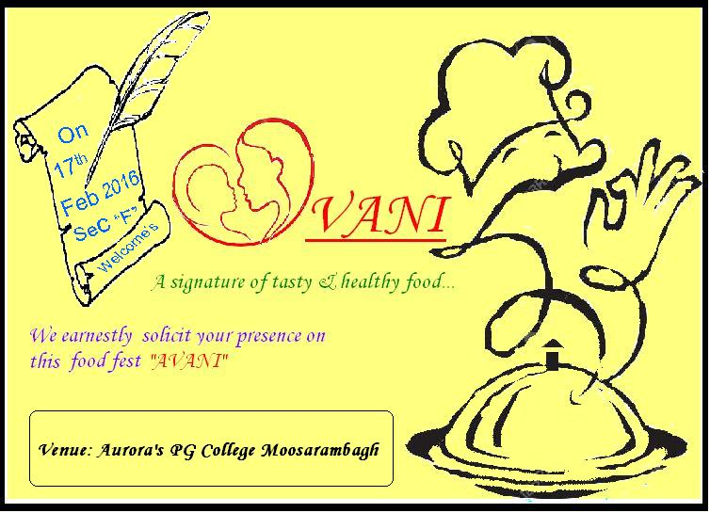

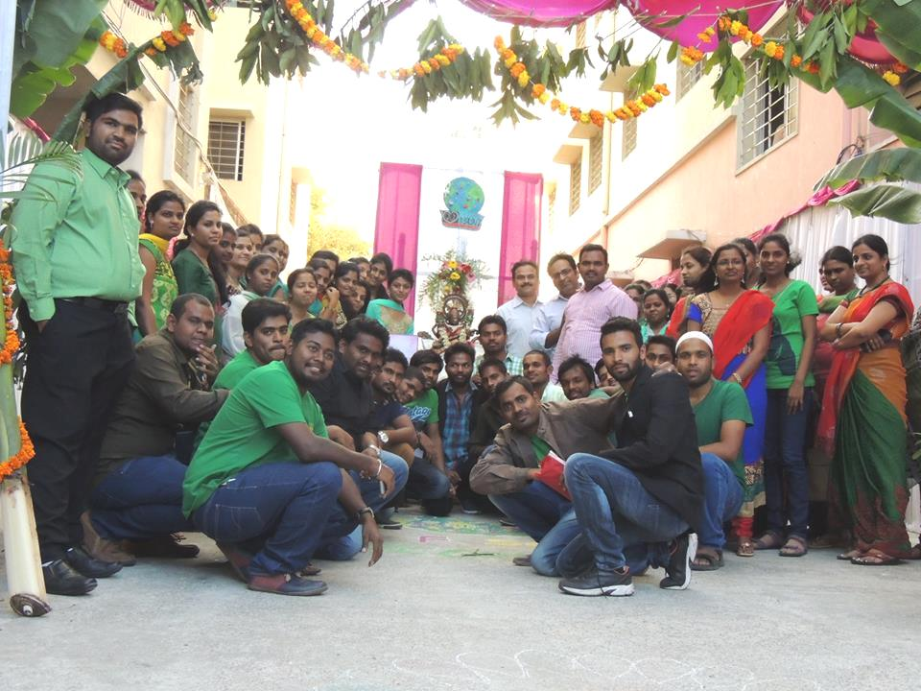

FDP on Multi Variate Data Analysis
